**PRODUCT Table and related data**

Consider the following product table. Product table contains the product name we sell, price of the product, what it is the cost and on what date it launched. Write the SQL’s to answer the following questions.

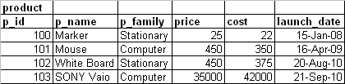

1. Write the select statement which gives all the products which costs more than Rs 250.
2. Write the select statement which gives product name, cost, price and profit. (profit formula is price – cost)
3. Find the products which give more profit than product Mouse
4. Display the products which give the profit greater than 100 Rs.
5. Display the products which are not from Stationary and Computer family.
6. Display the products which give more profit than the p_id 102.
7. Display products which are launched in the year of 2010.
8. Display the products which name starts with either ‘S’ or ‘W’ and which belongs to Stationary and cost more than 300 Rs
9. Display the products which are launching next month.
10. Display product name which has the maximum price in the entire product table.
11. List the product name, cost, price, profit and percentage of profit we get in each product.
12. Display how many products we have in Computer family which has the price range between 2000 and 50000.